Lab3: Advanced openstack operations

**Reference solutions**

1. Please make a screen shot for the rules of your new security group.

Answer: Student could have different security rules including TCP, UDP, SSH, ICMP and etcs. Some protocols should be configured for engress and ingress directions. An example is provided:



2. Submit the Logs you observe during the launching of the Ubuntu instance.

Answer: Student can obtain the logs from the detailed page of instance using “Log” option where the log files records the whole booting process. An example of the logs:

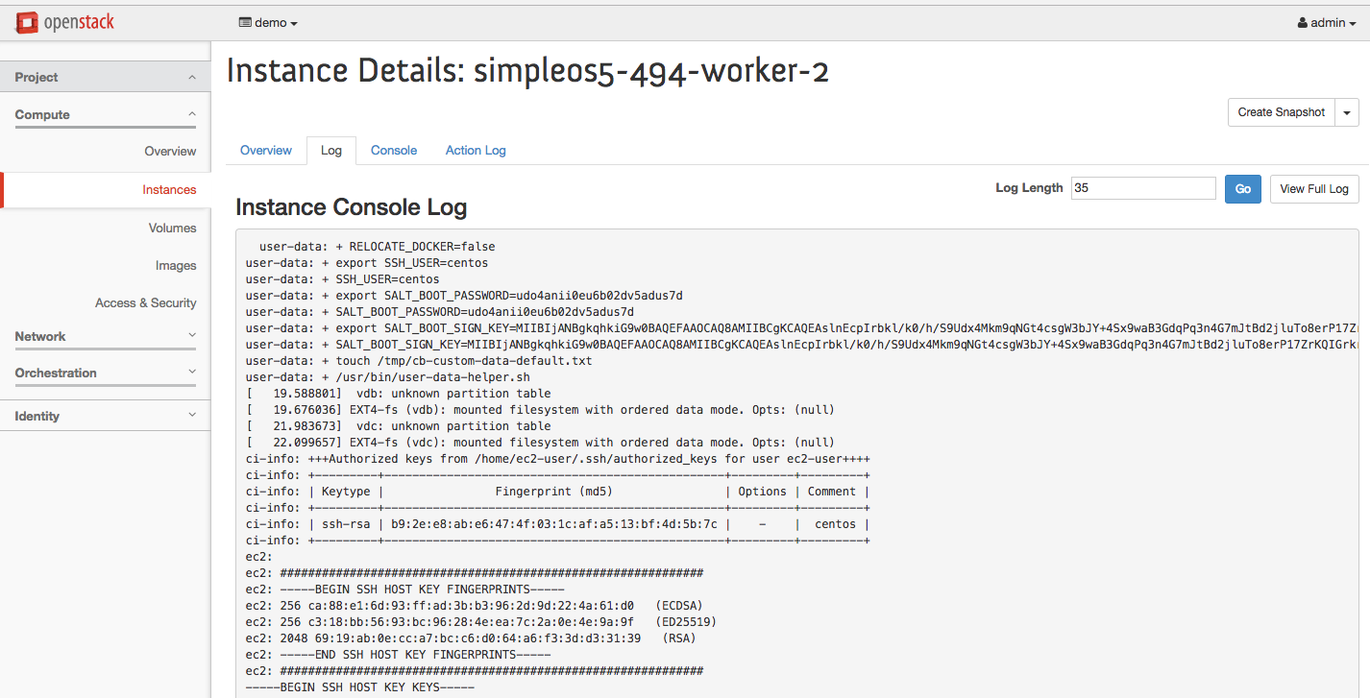

3. Please create a new folder after you ssh to Ubuntu. Name the folder with “Your Name_Lab3”.

Answer: Students can get the control of the Ubuntu instance only if they use right private keys and access to a floating ip. A successful remote access to the instance is:



4. Report the private IP and the floating IP associated with your Ubuntu instance.

Answer:

The private IP should in the format: 10.0.0.x. The floating IP can be a private IP or a public IP based the network environment when the OpenStack is installed.

An example is given below: (Ubuntu instance)

